CLINICAL EXERCISE PHYSIOLOGIST APPLICANT HELP GUIDE

Table of Contents
Equivalence pathway (applicants following a non-standard pathway to Clinical Exercise Physiologist registration) 2
The minimum entry requirements are: 2
Completing the form online 3
Indemnity Insurance Status 3
Current posts 3
Career History 3
All Qualifications and Professional Exams 4
References 4
Evidence of Clinical Practice 4
Membership of Professional Bodies 4
Disclosures 4
Declaration 4
Resources 5
Evidence for Clinical Practice Report Form 5
Application decision process 9
Reference Template 10

This guidance document has been provided by Clinical Exercise Physiology UK with the aim to assist applicants throughout the process of applying to become a Registered Clinical Exercise Physiologist with the Academy of Healthcare Science (AHCS). The current application pathway accessible for registration is via the Equivalence pathway (see below). To complete the application process, you will be required to upload various documents to the application form including certificates and transcripts, letter of reference and evidence of clinical practice form.

Equivalence pathway (applicants following a non-standard pathway to Clinical Exercise Physiologist registration)

In the absence of progression through the standard AHCS Clinical Exercise Physiologist pathway (i.e., completion of an AHCS accredited Clinical Exercise Physiology MSc degree), applicants can apply to become registered via the ‘equivalence’ pathway.

This pathway will be relevant to individuals working in the United Kingdom who have not completed the standard AHCS registration pathway. This pathway typically requires a minimum of 6 years training and experience in the UK, with evidence provided to indicate competent practice and underpinning knowledge, which is assessed by trained AHCS scrutineers. The 6-year period typically includes any relevant education and clinical practice.

To qualify for assessment via the equivalence pathway, evidence of relevant qualifications and experience must be provided. Please work through the Clinical Exercise Physiologist decision process below to identify the requirements for application.

The minimum entry requirements are:
- An undergraduate degree in sport and exercise science or relevant, related discipline
- A postgraduate degree in Clinical Exercise Physiology or relevant, related discipline, or professionally recognised and/or documented training in the health conditions outlined in the Clinical Exercise Physiologist scope of practice.
- Six years of relevant experience (including the time spent undertaking the relevant degrees)
Applicants will need to complete the Equivalence pathway, providing relevant supporting evidence including:
- Certificates and transcripts
- Evidence of clinical experience
- Reference from current or most relevant head of service/employer(s) supporting the level of competence and experience achieved.

To apply for, and remain on, the Register, all registrants must be practising and, as such, must abide by the AHCS Standards, including the requirement to undertake continuing professional development. ‘Practising’ is defined broadly as drawing on your professional skills and experience in the course of your work. This definition is inclusive of roles in clinical practice, education, management, research, and other related areas.

Completing the form online

Indemnity Insurance Status
If you provide clinical exercise physiology services directly to patients/clients as part of a commercial business, either through self-employment or a limited company, you will be required to supply details of your indemnity insurance status. Indemnity insurance can be purchased at a discounted rate by applying for a BASES membership and following the link to Towergate Insurance in the welcome email. To claim the discounted rate, you will need to ensure you specify 'British Association of Sport and Exercise Science' from the list when prompted for your Professional Association and provide your BASES membership number. You can also contact Towergate directly if you wish.
If you are currently employed within the NHS or by an employer that holds insurance on your behalf, you will need to state this in the application and provide the policy number and the expiry date.

Current posts
You will be required to provide information on your current post. If you are not currently in employment or self-employment, then you will be unable to apply at this time.

Career History
You will need to provide information regarding your career history, in chronological order, about each post you have held. Breaks in service can be indicated.

All Qualifications and Professional Exams
You will be asked to provide evidence of your qualifications and professional examinations. Evidence of previously completed degree programmes must include copies of your module transcripts. Please note in the absence of a relevant, related post graduate degree, you will be required to display professionally recognised and documented training in the health conditions outlined in the Clinical Exercise Physiologist Scope of Practice.

References
You are required to obtain a written reference to confirm that you have acquired the necessary skills and knowledge and are employed in a role which is eligible for registration. Please provide your referee with the provided template and upload alongside your application.

Evidence of Clinical Practice
To display your evidence of clinical practice, you will be required to complete an evidence of clinical practice report form, indicating your evidence of additional training and experience. Click here to access Evidence of Clinical Practice Report Form Template. Guidance on how to complete this can be found below in this document. If you do not use the required form, your application will likely be declined.

Membership of Professional Bodies
Enter details of any professional bodies of which you are a member, and upload certification or proof of membership.

Disclosures
Ensure that you answer all disclosure statements truthfully and honestly.

Declaration
Download and print the declaration form during the application process. This needs to be hand signed by you and re-uploaded and attached to the application.
Initial registration completed

Resources

Evidence for Clinical Practice Report Form

The guidance for report form allows the assessors of your application to be able to assess your level of knowledge, skills and demonstrated competence within each of the health conditions listed in the Clinical Exercise Physiologist Scope of Practice. A copy of the form can be found here.
Below are some examples of the information you could provide within the form.
Element 1. Summary of hours and location of experience
This section allows you to demonstrate the number and location of hours experience where you have applied knowledge and skills and demonstrated competence working with service users with health conditions. You are required to specify where you have worked with service users with a health condition that was a main/leading condition and where this was a secondary condition or comorbidity of the care and treatment.

Element 2. Summary of your work with specific conditions and roles/responsibilities
This section allows you to provide information regarding the specific conditions that you regularly work with on a day-to-day basis and your core roles and responsibilities as part of this care.
For example:
Health Condition | List specific conditions that you regularly work with on a day-to-day basis | Identify your core roles and responsibilities as part of this care
Cardiovascular | CAD, CHF, PAD, ACHD, autonomic dysfunction, pulmonary hypertension | Exercise Physiologist/ Senior Clinical Exercise Physiologist/ Service Lead/Researcher - leadership, management, assessment, prescription, delivery, supervision, instruction.

Elements 3a-d. Summary of your knowledge, skills and experience related to the CEP scope of practice and standards of proficiency
For those conditions that you have outlined as working with in element 2 above, describe how you have applied your knowledge and skills and demonstrated competence (100 words max).
- Risk stratification and screening decision making
This section is relevant to CEP Scope of Practice - Criterion 5a, 5b & 5c.
For Example:
Health Condition | Outline your knowledge skills and experience in:  - Assessing and stratifying exercise related risk using evidence-based tools.  - Obtaining relevant health information and medical history  - Strategies and measurements used to assess and manage health status  - Methods used to record and report changing risk factors and adverse signs and symptoms.
Cancer | I receive and evaluate participants’ medical history either provided by the oncologists / CNS when referred directly from the oncology setting or through initial consultations with patients / participants self-referred or linked to a community-based programme. Cancer related health status and risk stratification is undertaken using a combination of the CanRehab guidelines, the Royal College of Anaesthetists’ prehab guidance and ACSM screening tools. I use the CanRehab guidelines detailing the four categories of cancer specific risk factors/ adverse events that should be monitored and how to record and report changing cancer related risk factors.

- Assessment of health status and functional capacity
This section is relevant to CEP Scope of Practice - Criterion 5a, 5d & 5e.
For example:
Health Condition | Outline your knowledge, skills and experience in:  - Performing appropriate assessments (e.g. functional capacity, patient reported outcomes)  - Evaluating capacity to perform exercise  - Reporting clinical status
Cardiovascular | Sub-maximal functional capacity assessments (submax bike, step, ISWT, isometric leg strength) for clinical rehabilitation programmes and research projects (cardiovascular fitness, muscular strength/endurance, balance, agility, spirometry) >2500 tests.  Maximal cardiopulmonary exercise testing for clinical diagnostic screening, pre-surgical assessment, rehabilitation programmes, and clinical research >400 tests.

- Design of Exercise Intervention
This section is relevant to CEP Scope of Practice - Criterion 5a & 5f.
For example:
Health Condition | Outline your knowledge, skills and experience in:  - Designing safe and effective exercise plans  - Utilising optimal modes, frequencies, intensities, durations and volumes of exercise  - Recognising the risks and benefits of different forms of exercise training  - Designing appropriate regressions, adaptations and progressions
Respiratory | All programming linked to FITT principles focusing on adaptations and progressions, functional ADLs and translation into real-world activities such as mimicking movement patterns (in safe, supervised environment) that required improvement to aid QoL. All programming was individualised even within group formats due to manipulation of HR, RPE, pain scales, clinical signs / risks, SOB risks, fatigue and motor function. Components of programme were adapted, e.g., gradual, dynamic warm up in extended formats to avoid exacerbation and including `main session` movements to prepare for work ahead (back end of w/up). Cool down allowed movement and flexibility based on individual needs that were previously assessed, i.e., extended CV element with tightness address through prescriptive stretching were required (development / maintenance).  All components were adapted based on clinical signs, performance capacity and goals – easiest / most simplistic exercises initially with gradual progressions and manipulation of FITT.

- Exercise delivery and leadership.
This section is relevant to CEP Scope of Practice - Criterion 5a, 5f & 5g.
For example:
Health Condition | Outline your knowledge, skills and experience in:  - Delivering safe and effective exercise sessions, adapted for individual and exercise environment needs  - Monitoring and identifying adverse signs and symptoms during exercise sessions and recovery
Cardiovascular | During exercise sessions, observing for any losses of muscle power and coordination, and general power and depths of breathing. Signs of holding ache joints. Ensuring, patients feel well and invigorated after an exercise session.  Reporting if the exercise exacerbated expected side effects, of medications (dizziness, fatigue) and presence of any chest tightness, joint/muscle aches and palpitations, arrhythmias/breathlessness.

- Behavioural change and psychology support.
This section is relevant to CEP Scope of Practice - Criterion 5a, 5h & 5i.
For example:
Health Condition | Outline your knowledge, skills and experience in:  - Supporting learning to self-regulate physical activity behaviour and planning for long-term physical activity maintenance  - Recognising barriers and motivators to exercise and factors that affect long-term exercise adherence and compliance  - Utilising lifestyle strategies, programmes, and resources, including government and community-based population-wide strategies pertinent to supporting physical activity behaviour change  Please try to outline for which health conditions you have experience in applying this.
Respiratory | Individual behavioural assessments and motivation in formalised consultations via motivational interviewing techniques and readiness to change questionnaires. We often (in group settings) provided education sessions to support physical activity behaviour, this focused on lifestyle changes and health behvaiours that could be adopted daily. In addition subjective questionnaires were used pre & post intervention to monitor PA levels and some behaviours, e.g., IPAQ, etc. We did ask certain patients in some services to keep reflective diaries that can support person-centred goal achievements and tracking.

Application decision process
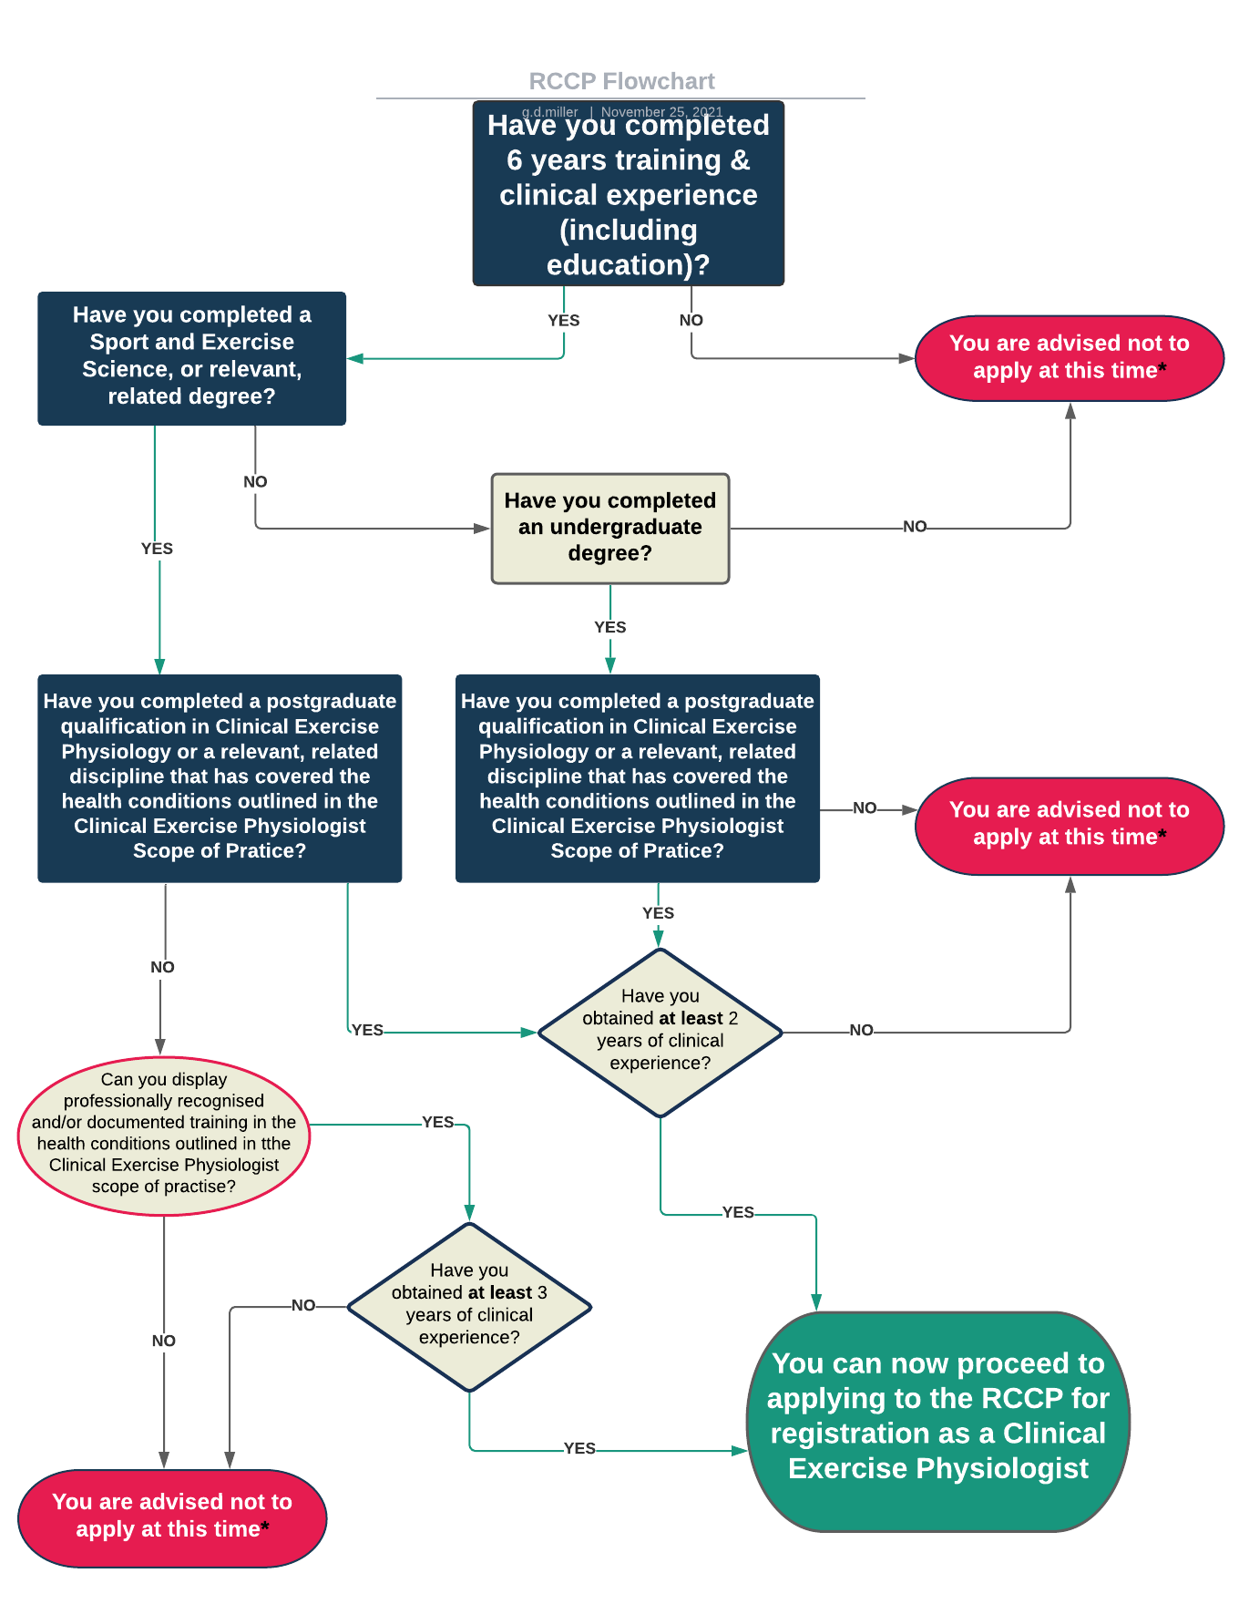

Reference Template
Please use the below template or the one provided by the AHCS.
Must be supplied on headed paper
Referee Name and Address
Re: Name of Applicant
Position currently held: Applicant current job role
Dates of Employment: Date started employment
Contracted hours per week: Number of hours per week completing current job role
Can you confirm that you are familiar with the CEP-UK scope of practice, and that the applicant’s responses to the following sections are accurate. By initialling each section, you are confirming that, to the best of your knowledge, the applicant has provided a genuine account of their knowledge, skills and experience:
Experience of working within each of these long-term health conditions
Knowledge, skills and competence of the following for those conditions outlined above as within the scope of practice:
. Risk Stratification and Screening

Assessment of health status and functional capacity
Design of Exercise Interventions
Exercise delivery and leadership
Behavioural change and psychology support

Please provide a further statement in support of the applicant’s application to become a Registered Clinical Exercise Physiologist (max 350 words).
Name:

Position held:

Signed:

